**Covid-19 Vaccines Analysis**

TEAM MEMBER

PHASE-2

732521104037: PRAVEEN N

PHASE2: SUBMISSION DOCUMENT

PROJECT: COVID-19 VACCINESS ANALYSIS

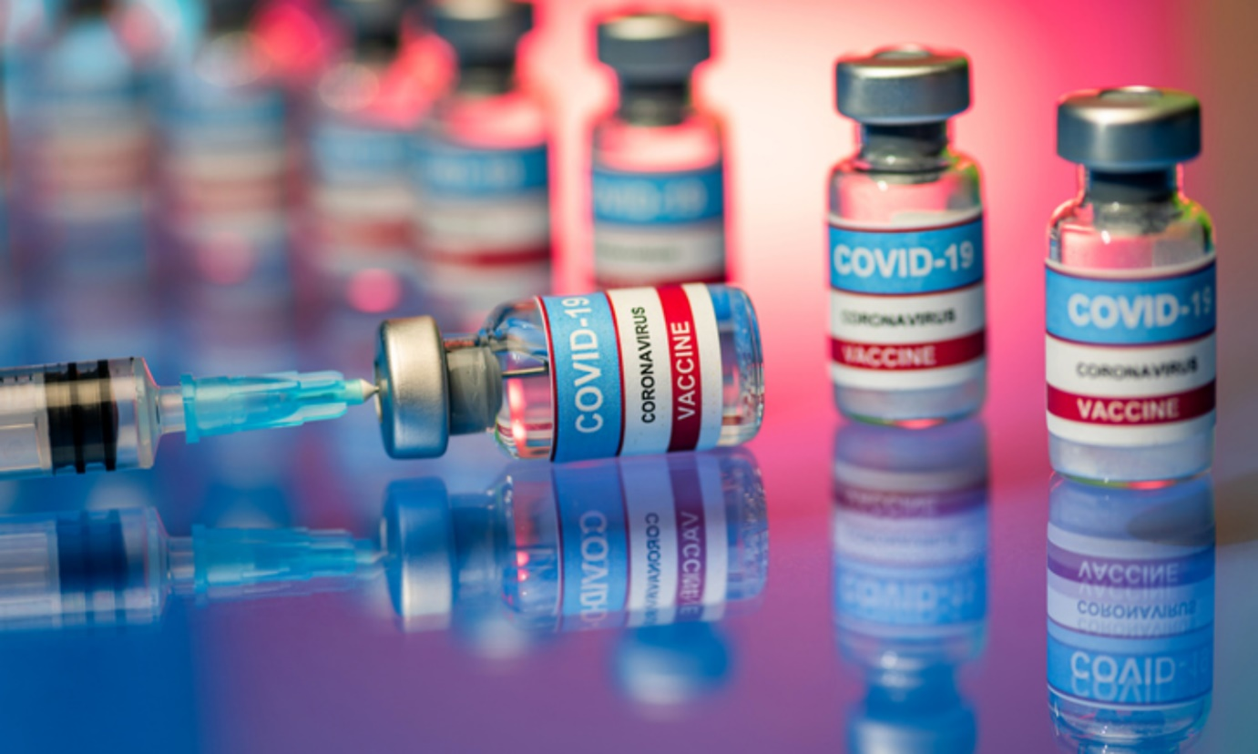

**INTRODUCTION:**

Safe and effective vaccines are an important tool, in combination with other measures, to protect people against COVID-19, save lives and reduce widescale social disruption.

The main objective of this project to analyze Covid – 19 Vaccination data and find out some important insights.

**Methodology:**

* In the Country, Vaccination data set the first column is that Country in country column presents different countries.
* In the iso code column containing the iso code for the country. and in the data set contain a date for Vaccination.
* Another column is total Vaccination, People Vaccination, People fully Vaccination, Daily Vaccinated raw, Daily Vaccinations, Total Vaccinations per hundred, people Vaccination per hundred, People fully Vaccinated per Hundred, and Daily Vaccination per million in all columns Show how many people are Vaccinated in different criteria.

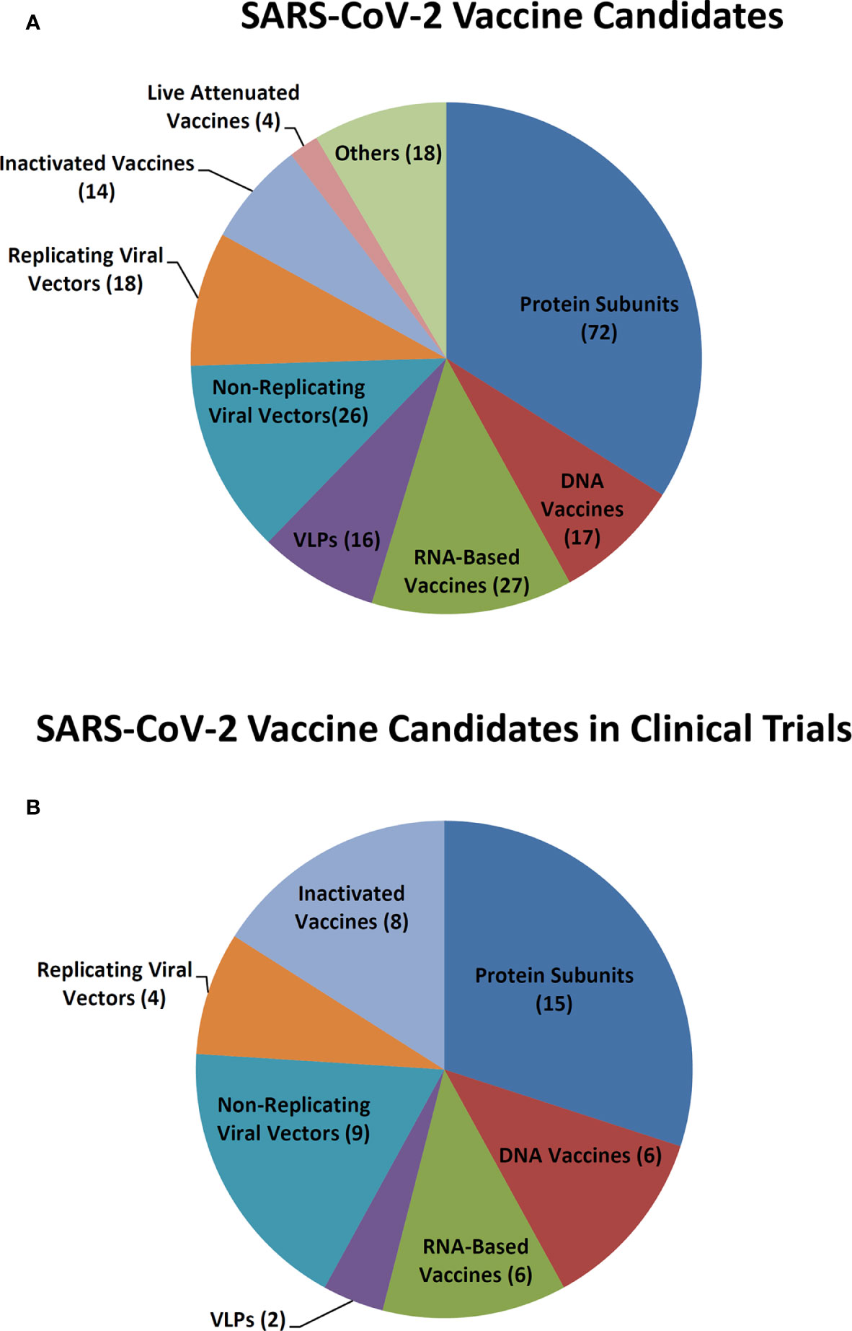

**Dataset Link:**[**https://www.kaggle.com/datasets/gpreda/covid-world-vaccination-progress**](https://www.kaggle.com/datasets/gpreda/covid-world-vaccination-progress)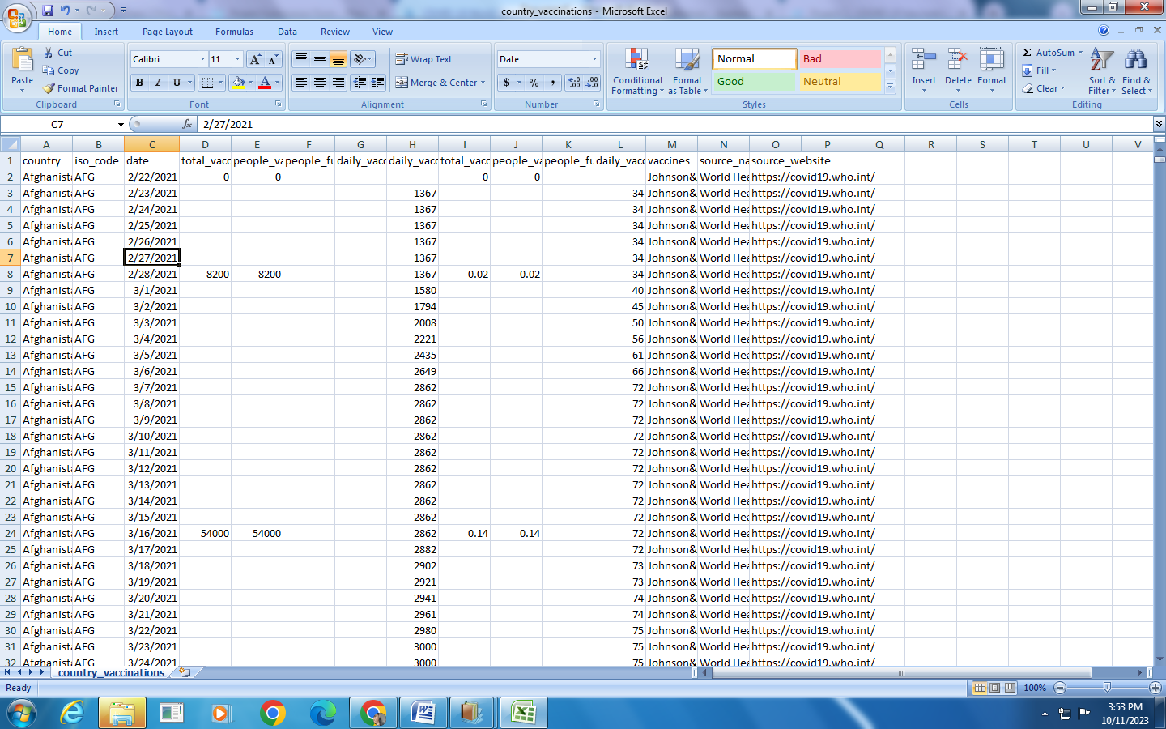

**Recommendations:**

* We can analyze the data of the overall world.
* Like this dataset, we can perform operations with various categories, city-wise, or Region wise.
* We can analyze the data with the proper format
* We can collect good datasets for more effective analysis by using charts.

**Conclusion:**

* In China and India in these two countries, most people are Vaccinated.
* In 2021 60.79% of people are fully Vaccinated and in 2020 only 39.2 % of people are fully Vaccinated.
* China, India, the United States, Brazil, Indonesia, Germany, the United States, Turkey, France, and England There are the top 10 countries is completed the full Vaccinations.